|  |  |
| --- | --- |
| Group Members | 3 |
| Name | Seongku (Daniel) Ahn  Ankit Chutani  Twinklepreet kaur |
| Student ID | 300286629  300289566  300289692 |

Project Proposal

CSIS3275 – 053, Software Engineering Project

Instructor: Rahim Virani

2019

**Movie Information System**

1. **Overview:**

This report provides the technical document of movie information system or movie database (MIS or MDB). This web application is for customers who retrieve the movie information. Every feature is implemented by its specific role. This application is useful for people who want to systematically arrange the movie database with role as well as people to enjoy watching the movies. For better and improved UX/UI design and performance of the project, some requirements and features may be changeable in progress.

* 1. **Team members**
* Seongku (Daniel) Ahn as scrum master and programmer
* Ankit Chutani as DBA and programmer
* Twinklepreet Kaur as programmer
  1. **Scope of project**
* **Product and features**: This application is basically the information system for general users, but as the role of users the menu displays differently. That is, it works as SaaS and role management feature is included. Therefore, the menu consists of ‘home’, ‘login’, ‘user management’, ‘movie information (add/delete)’, ‘admin (role management)’. To meet the appropriate scope by the instructor and adjust each member’s ability and background, we mainly focus on the essential functions. This is because the most significant point is to follow software engineering concept from class. If we get the descent output in every sprint, we can extend the additional features.
* **Target audience:** people who love movies
* **Similar systems**: IMDB and Rotten tomatoes
* **Differences**: this application helps people who want to manage own movie database easily as well as they retrieve it.
  1. **Objects of project**

This application has four objects; general users who log in and use this system, a database administrator who manage the data for movies, a user manager who handle users, and an administrator who take care of the whole system. The role for each object states in the next section 1.4.

* 1. **Group Dynamics: R&R (Role and Responsibilities)**
     1. **main role for each object:**

administrator/user manager (Daniel)

movie database administrator (Ankit)  
 general user (Twinkle)

* + 1. **documentation and printing:**

everybody

* + 1. **meeting room management and meeting minutes:**

everybody

* + 1. **development of components:**

- framework, menu, UX/UI design (Daniel)

- login/user registration (Twinkle)

- update movies: movie data with SQL (Ankit)

- admin role management (Daniel)

- test with Junit and Selenium (everybody)

* 1. **Use cases**
     1. **Login the system**
     2. **Search database**
     3. **Add new data to MIS**
     4. **Delete a data to MIS**
     5. **Register a user (Sign up)**

**Use case**: Register to the MIS

**Primary actor**: General user

**Goal in context**: To register to the MIS when the user visits the MIS

**Precondition**: MIS has been installed properly and a user can access the correct URL

**Trigger**: In the login page, click ‘Sign up’ button

**Scenario**:  
1) User: type the MIS URL to access the system

2) User: click ‘Sign up’ button under log in page

3) User: input the user profile

4) User: click ‘Submit’

**Exceptions**:

1. The server or database is not installed properly, then it shows error message when click the ‘Sign up’
2. Invalid ID, name and password are input in the registration form: ‘Submit’ doesn’t work.
3. Duplicate ID does not allow in the registration form: ‘Submit’ doesn’t work.

**Priority**: Essential, must be implemented before login

**When available**: In the first login page

**Frequency of use**: Once

**Channel to actor**: Via web browser

**Secondary actors**: User manager or Administrator

**Channels to secondary actors**: Support via email address

**Open issues**:

1. Is there a way to change the user ID?
2. Should the administrator assign the role to users?
3. Is there a way to approve without user ID?
   * 1. **List up users**

**Use case**: Display user list which registered in the database

**Primary actor**: User manager

**Goal in context**: To show what users exist and verify the current status

**Precondition**: User manager account. MIS has been installed properly and a user can access the correct URL

**Trigger**: In the main page, click ‘User’ menu

**Scenario**:  
1) User manager: type the MIS URL to access the system

2) User manager: log in the page (if there is not account for user manager, create this first. Refer to 1.5.5)

3) User manager: click ‘User’ menu

4) User manager: display the list of users with status

**Exceptions**:

1. The server or database is not installed properly, then it shows error message when click the ‘Sign up’.
2. This function only is implemented by user manager or administrator.
3. If there is no user to register, it will only show user manager and administrator.
4. The list displays a page with the limits of account up to maximum 20.

**Priority**: Essential for user manager to check and manage the current users

**When available**: In the menu bar of the main page

**Frequency of use**: Whenever click the ‘User’ menu

**Channel to actor**: Via web browser

**Secondary actors**: Administrator

**Channels to secondary actors**: Support via email address

**Open issues**:

1. Is there a way to show the user list by order?
2. Should the user manger (including administrator) access this menu?
3. How many users can display a page?
   * 1. **Remove a user**

**Use case**: Remove a user which registered in the database

**Primary actor**: User manager

**Goal in context**: To remove a user from the database

**Precondition**: User manager account is needed. MIS has been installed properly and a user can access the correct URL

**Trigger**: In the main page, click ‘User’ menu

**Scenario**:  
1) User manager: type the MIS URL to access the system

2) User manager: log in the page (if there is not account for user manager, create this first. Refer to 1.5.5)

3) User manager: click ‘User’ menu

4) User manager: display the list of users with status and there is a button to delete a user

**Exceptions**:

1. The server or database is not installed properly, then it shows error message when click the ‘Sign up’.
2. This function only is implemented by user manager or administrator.
3. If the list only shows user manager and administrator, then there is no user to remove. This is because they are users given by default.
4. Only a user can be erased at a time.

**Priority**: Essential for user manager to manage the current users

**When available**: In the menu bar of the main page

**Frequency of use**: When choose a user and click ‘Delete’ button

**Channel to actor**: Via web browser

**Secondary actors**: Administrator

**Channels to secondary actors**: Support via email address

**Open issues**:

1. Is there a way to roll-back the removed in the user list?
2. Should the user manger (including administrator) access this menu?
3. How many users can delete at a time?
   * 1. **Assign the role to a user**

**Use case**: Assign the role to a user which registered in the database

**Primary actor**: Administrator

**Goal in context**: To map a user with the one of proper roles from the database

**Precondition**: Administrator account is needed. MIS has been installed properly and a user can access the correct URL

**Trigger**: In the main page, click ‘Admin’ menu

**Scenario**:  
1) Administrator: type the MIS URL to access the system

2) Administrator: log in the page

3) Administrator: click ‘Admin’ menu

4) Administrator: there is a button to map a user with the roles such as guest, database administrator, user manager

**Exceptions**:

1. The server or database is not installed properly, then it shows error message when click the ‘Sign up’.
2. This function only is implemented by administrator.
3. If the list only shows user manager and administrator, then there is no user to assign. This is because they are users given by default.
4. Only a user can be assigned at a time.

**Priority**: Essential for administrator to manage the current users

**When available**: In the menu bar of the main page

**Frequency of use**: When choose a role for a user and click ‘Assign’ button

**Channel to actor**: Via web browser

**Secondary actors**: None. Administrator only

**Channels to secondary actors**: Support via email address

**Open issues**:

1. Is there a way to add more roles for users?
2. Can the administrator only access this menu?
3. How many users can assign at a time?
   1. **Use case diagram (summary)**

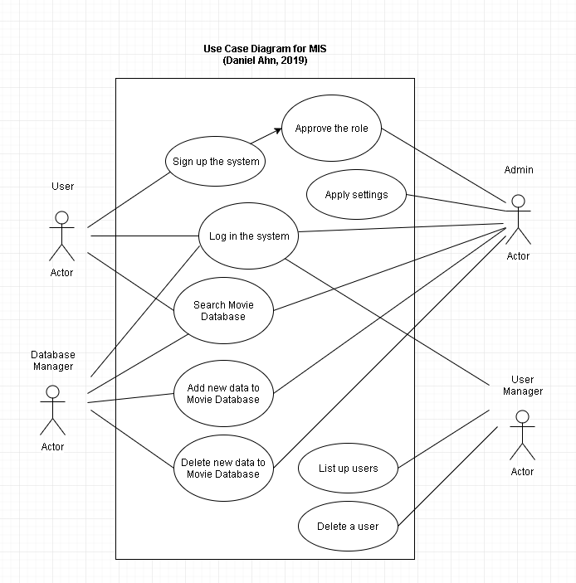

* 1. **Software toolset**
     1. **External components and 3rd party components**

This application interact with some external components; Java runtime environment, Spring framework with Tomcat as web server, and MySQL for DBMS. These components are well-known framework and programs for developing web server application. In addition to that, it is the useful development environment to satisfy the labs in class such as Junit for back-end logic test, Selenium for web behavior test, Jenkins for release, Github for code maintenance and defect tracking, and Trello for Kanban board in real world. Therefore, we chose these components.

* + 1. **Metrics**

This application is based on web application. Therefore, the performance about web application is necessary such as average connect time to web server, average response time for adding data to server, time to first byte and error rate.

* 1. **Project layout and architecture: TBD**
  2. **Project Schedule**

The following Gantt chart for MIS project. It starts from 3rd, January to 21st, March. The schedule follows the timeline of class and every week has a meeting to review the progress for Agile. Every two week is regular sprint, but we are going to have a small meeting at least every week.

* This table and chart were created with Gantt chart in MS-Project 2016.

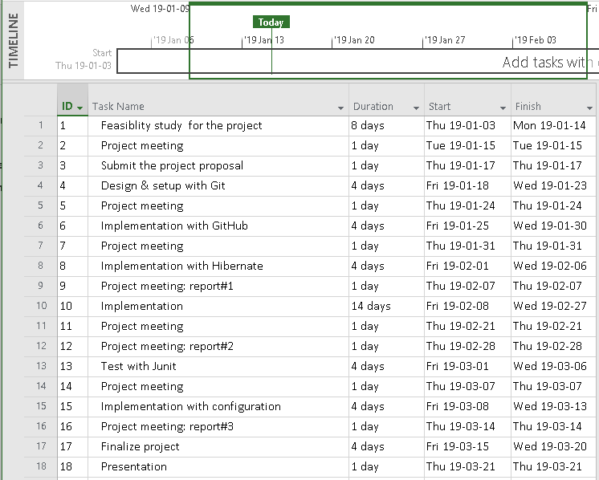

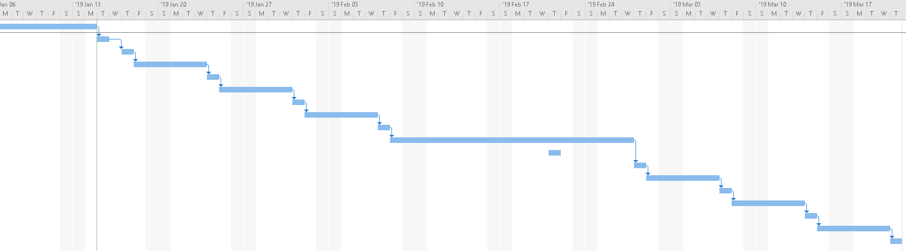

* 1. **Meeting Minutes**

This is attached as an appendix at the last page of this report. Also, this document uploaded to our project in Github and Kanban board (Trello).   
<https://github.com/danask/MDB/tree/master/meeting%20minutes>  
<https://trello.com/b/qAjP80XV/kanban-board-for-mis-project>